**1. Form View:**

Used to display a single record in a form. It's the default view for editing a record.

It allows users to see and edit the fields of a record in a structured way.

Example: Creating or editing a customer, sales order, or product.

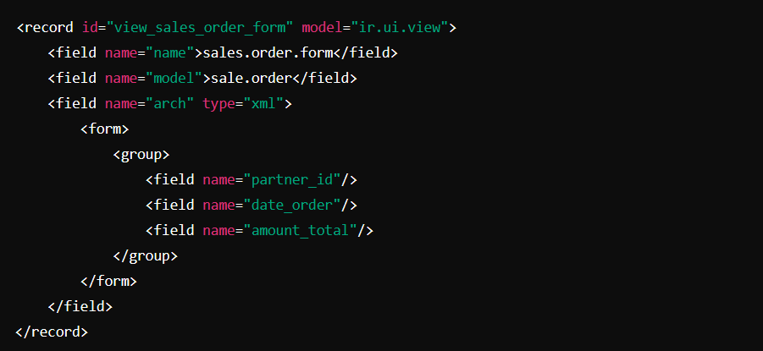

**2. Tree View (List View):**

Displays records in a tabular format (rows and columns).

It is used to show a list of records, like all sales orders or products.

Users can select, sort, and filter records directly in this view.

Example: Viewing a list of products or a list of invoices.

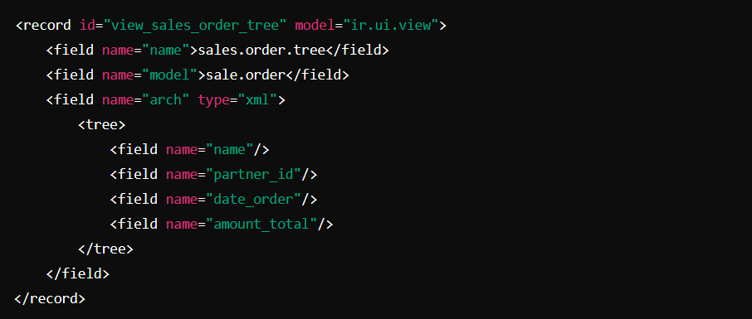

**3. Kanban View:**

Displays records as cards in columns, often used for managing workflows or tasks.

It's a visual representation of records that can be moved between different stages.

Example: Project management or task tracking where each task or project is represented by a card.

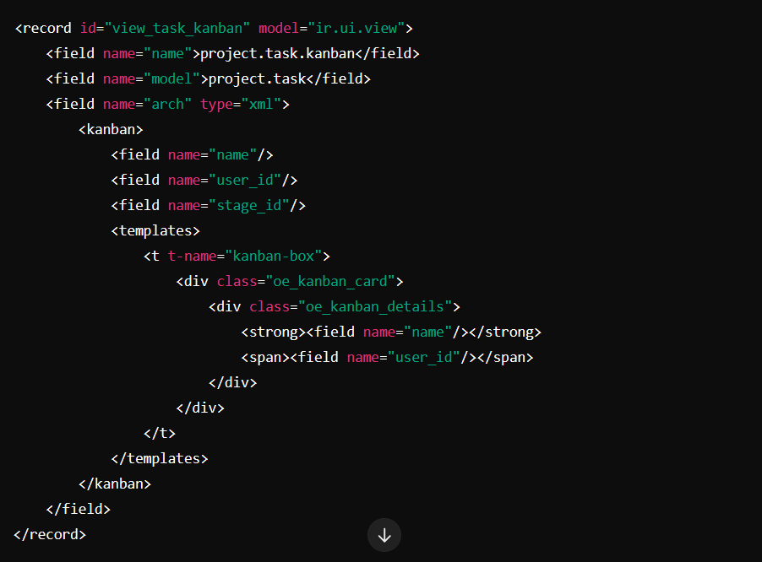

**4. Calendar View:**

Displays records on a calendar, showing their scheduled dates.

It's ideal for managing events, meetings, appointments, or activities.

Example: Viewing scheduled meetings or project deadlines on a calendar.

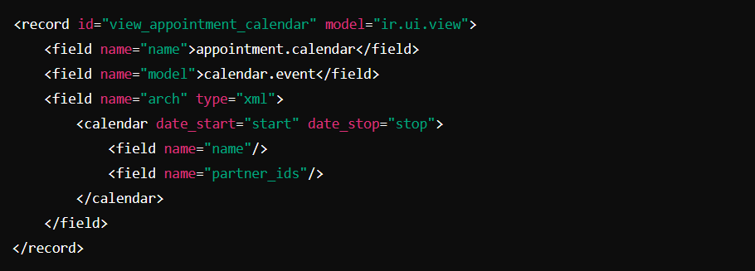

**5. Graph View:**

Used to display records in graphical formats like bar, line, or pie charts.

Useful for data analysis and reporting.

Example: Viewing sales reports, revenue trends, or task completion statistics in a chart format.

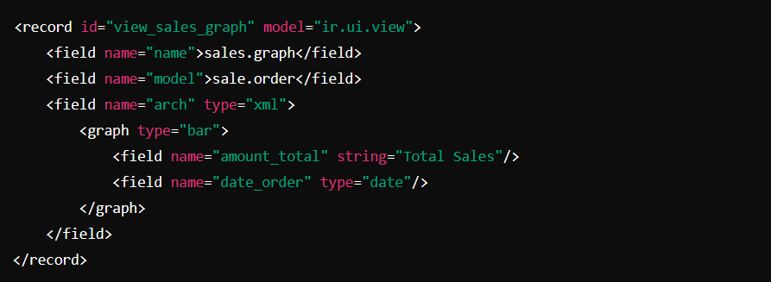

**6. Pivot View:**

Displays records in a pivot table format, allowing users to aggregate and summarize data.

It is useful for more complex reporting and analysis.

Example: Creating a pivot table for sales data by product and region.

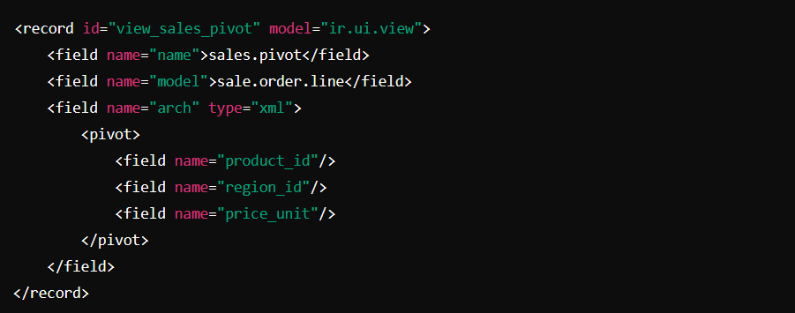

**7. Search View:**

Provides a search bar to filter records in any view (form, tree, etc.).

It is mainly used in conjunction with other views to allow users to search and filter data based on specific criteria.

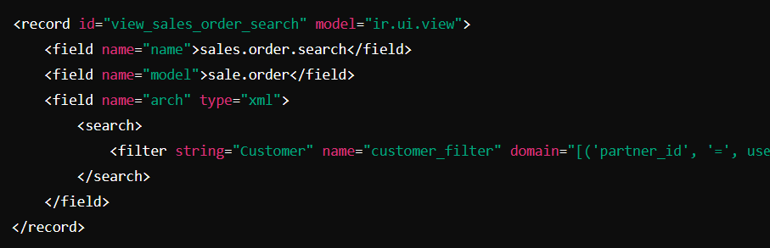

**8. Dashboard View:**

Combines multiple views (graph, pivot, and others) into one central view, offering a quick overview of important metrics.

Example: A custom dashboard displaying key performance indicators (KPIs) for a department.

